SOHAN M
1NT19IS155

Execrcise-4: Map Reduce (Programs)
Use the Hadoop framework to write a MapReduce program to read a .csv file into a single node
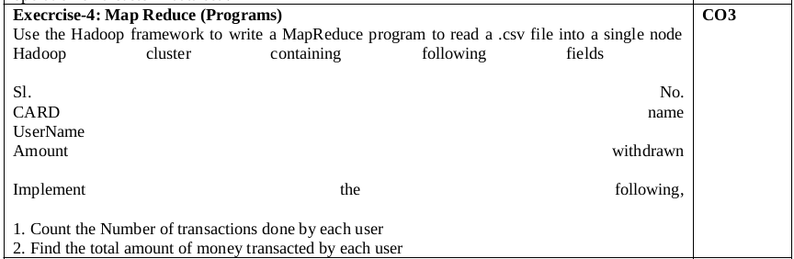

package BD4;

import java.io.IOException;
import java.util.*;
import org.apache.hadoop.fs.Path;
import org.apache.hadoop.io.*;
import org.apache.hadoop.mapred.*;

public class TransactionCount {
//MAPPER CODE

public static class Map extends MapReduceBase implements
Mapper<LongWritable, Text, Text, IntWritable> {
private final static IntWritable one = new IntWritable(1);
//private Text word = new Text();

public void map(LongWritable key, Text value, OutputCollector<Text,
IntWritable> output, Reporter reporter) throws IOException {
String myString = value.toString();
String[] userCount = myString.split(",");
output.collect(new Text(userCount[3]), one);

}
}

//REDUCER CODE
public static class Reduce extends MapReduceBase implements
Reducer<Text, IntWritable, Text, IntWritable> {
public void reduce(Text key, Iterator<IntWritable> values,
OutputCollector<Text, IntWritable> output, Reporter reporter) throws
IOException { //{little: {1,1}}
int finaluserCount = 0 ;
Text mykey = key ;
while(values.hasNext()) {
IntWritable value = values.next();
finaluserCount += value.get();
}
output.collect(mykey, new IntWritable(finaluserCount));
}
}
//DRIVER CODE
public static void main(String[] args) throws Exception {
JobConf conf = new JobConf(TransactionCount.class);
conf.setJobName("wordcount");
conf.setOutputKeyClass(Text.class);
conf.setOutputValueClass(IntWritable.class);
conf.setMapperClass(Map.class);
conf.setCombinerClass(Reduce.class);
conf.setReducerClass(Reduce.class);
conf.setInputFormat(TextInputFormat.class);
conf.setOutputFormat(TextOutputFormat.class);
FileInputFormat.setInputPaths(conf, new Path(args[0]));
FileOutputFormat.setOutputPath(conf, new Path(args[1]));
JobClient.runJob(conf);
}

}

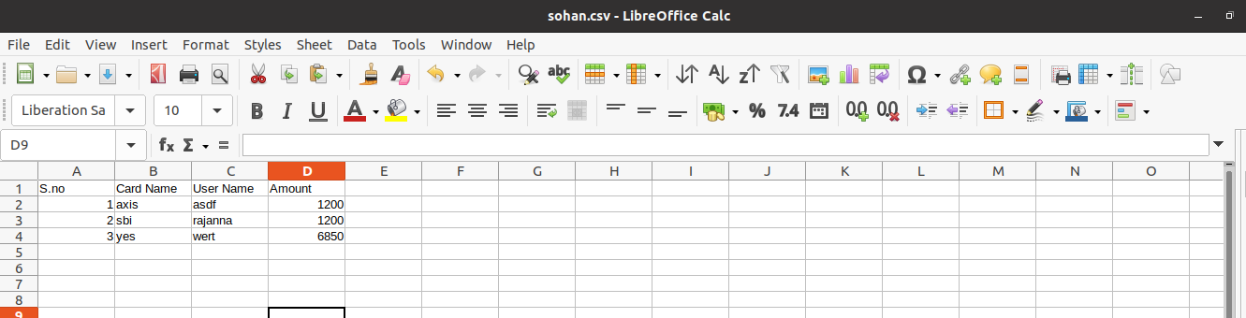
cd $HADOOP_HOME
cd sbin
~/hadoop-3.2.1/sbin$ start-all.sh
jps

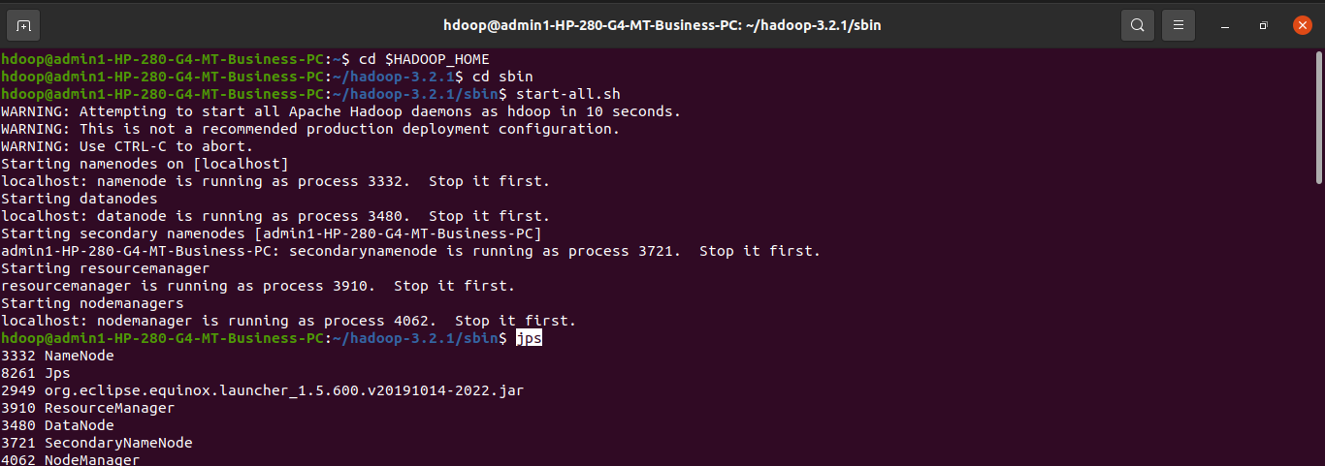
hdfs dfs -mkdir -p /input155

hdoop@admin1-HP-280-G4-MT-Business-PC:~/hadoop-3.2.1/sbin$ hdfs dfs -mkdir -p /input101
hdoop@admin1-HP-280-G4-MT-Business-PC:~/hadoop-3.2.1/sbin$ hdfs dfs -copyFromLocal /home/hdoop/Desktop/sohan.csv /input101

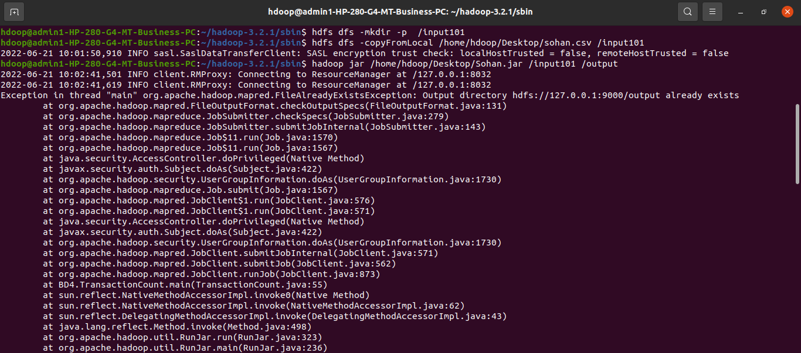

hadoop jar /home/hdoop/Desktop/Sohan.jar /input101 /output101
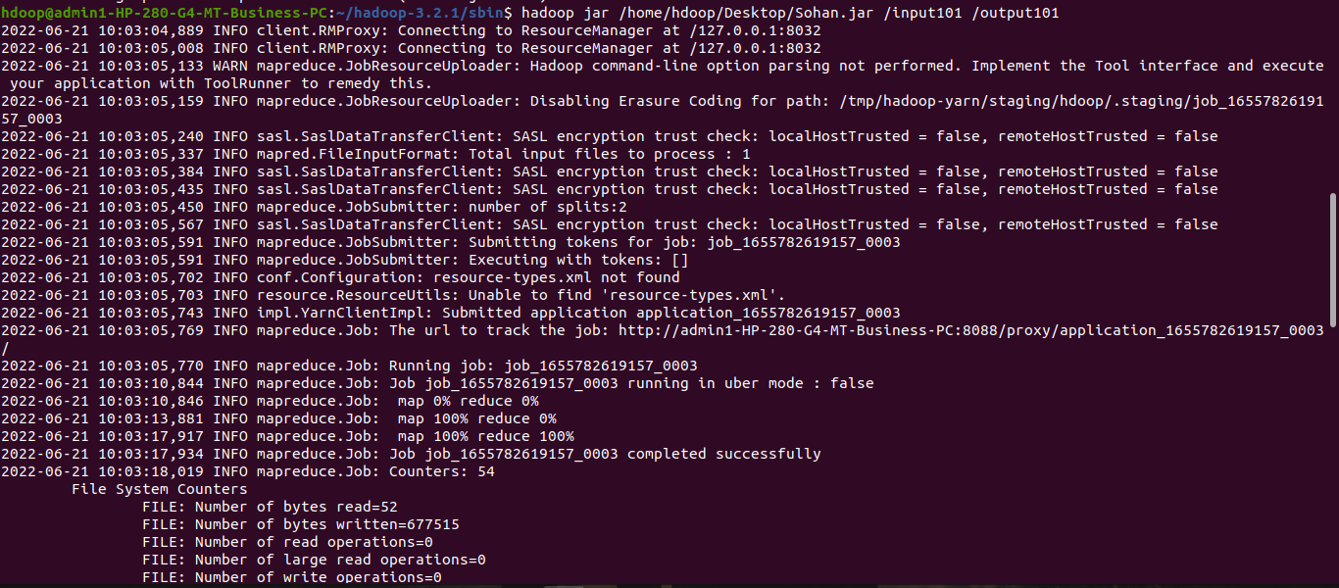

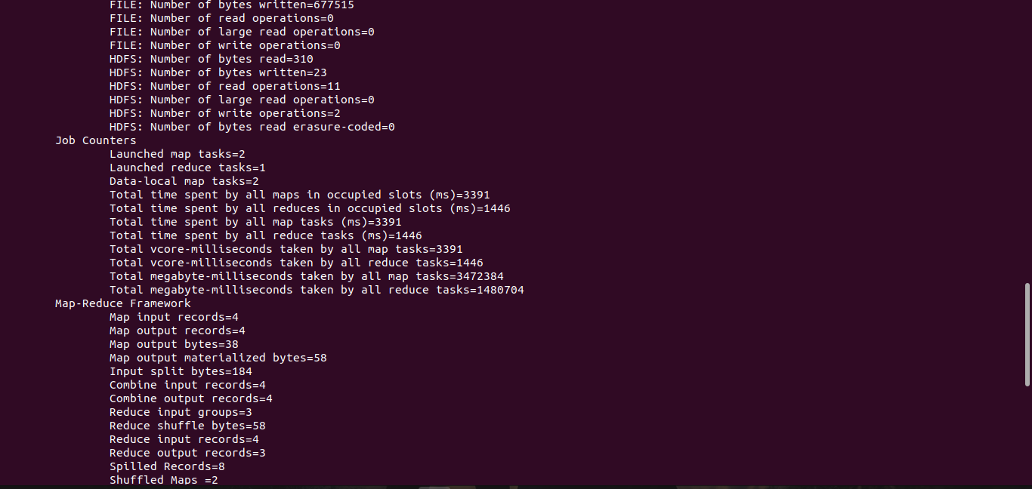

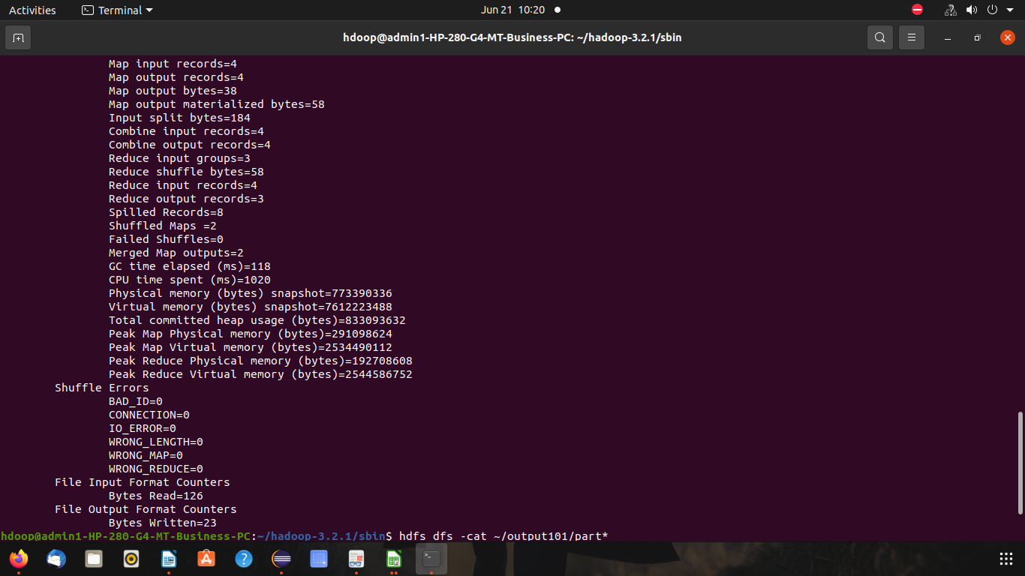

hdfs dfs -cat /output101/part*

